

###### **April 28, 2017**

##### Mrs. Maley-Mrs. Pater-Mrs. Terenzi-Ms. Versteegden



**Upcoming Dates**

**What’s Happening In 2nd Grade**

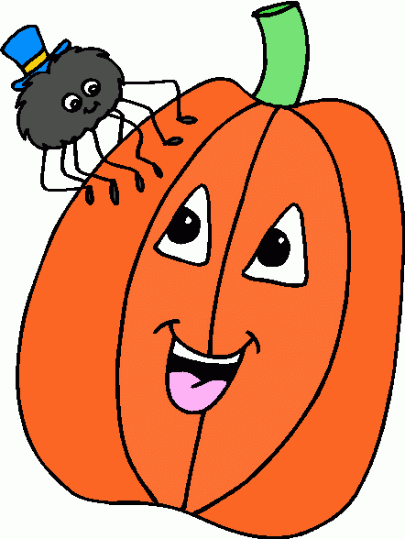

**1. job**

**2. pot**

**3. nod**

**4. top**

**5. not**

**6.dot**

**7. fox**

**8. mop**

**9. spot**

**10. hop**

**11. pop**

**12. drop**

**13. on**

**14. box**

**15.pocket**

**16.hospital**

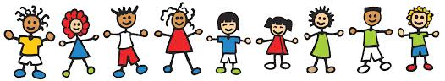

**May 15th - 19th**

Spring Book Fair

**May 26th & 29th**

No School

**June 7th**

Field Day

**June 9th**

School Carnival

**June 15th**

Last Day of School

Half Day

**April 10th – May 5th**

MSTEP testing (upper el)

**May 2nd**

Hungry Howie’s Night

GPTO Meeting

**May 5th**

Fun Run

**May 15th**

2nd Grade Field Trip

**May 16th**

Blood Drive

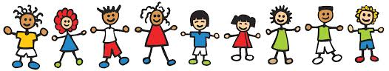

**Additional Information**

*Throughout the month of May, many of our special times will be changing to allow the upper grades to have uninterrupted work time during their MSTEP testing.

*Please be sure to return any Fun Run donation envelopes. Graebner really appreciates your help!

*We are collecting **Detroit Sports** items for the **2nd Grade Carnival Basket**. Thank you for your donations.

**This week in Review**

-Reading/Writing-

**Unit 3.3**

**Comprehension Strategy:** ask and answer questions

**Comprehension Skill:** author’s purpose

**Vocabulary Strategy:** synonyms & antonyms

**Writing Traits:** organization, word choice, voice

**Grammar:** past and future tense verbs

**Structural Analysis:** contractions with not

**Mechanics:** letter punctuation-greeting and closing

**Concept Map:** Brace Map

**Genre**: narrative nonfiction

*Unit Assessments

-Math-

*We determined if shapes are 2D, plane, or 3D, solid. We also discussed each shapes properties.

**Vocabulary:** side, edge, corner, vertex, apex, face, 2-dimensional,

3-dimensional, angle, circle, square, rectangle, triangle, circle, pentagon, hexagon, polygon, rhombus, trapezoid, quadrilateral, turn, flip, slide, open figure, closed figure, attribute, congruent, symmetry

-Social Studies**/Science**-

**Landforms**

*We continued learning about different landforms found on Earth’s surface.

**Vocabulary**: hill, mountain, island, volcano, desert, plain, canyon, valley, lake, river, ocean, weathering, erosion

1. port

2. north

3. more

4. store

5. oar

6. roar

7. board

8. part

9. start

10. park

11. first

12. hurt

13. ago

14. carry

15. people

**Spelling List for Next Week:**

**-or, -oa, -ar, -ore**

**Homework**

**\*Geometry Practice Sheet**

**Due: Monday, May 1st**

**\*Reading Fluency Homework**

**Due: Friday, May 5th**