

###### **December 22, 2016**

##### Mrs. Maley - Mrs. Pater-Mrs. Terenzi-Ms. Versteegden

**Upcoming Dates**

**What’s Happening In 2nd Grade**

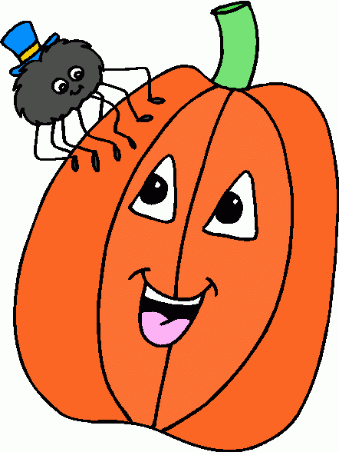

**January 16th**

Dr. MLK Jr. Observance-

NO School

January 19th and 20th

½ Days

End of Quarter 2

**1. job**

**2. pot**

**3. nod**

**4. top**

**5. not**

**6.dot**

**7. fox**

**8. mop**

**9. spot**

**10. hop**

**11. pop**

**12. drop**

**13. on**

**14. box**

**15.pocket**

**16.hospital**

**December 23rd –January 3rd**

Winter Break

**January 4**

School Resumes

**January 10th**

GPTO Meeting

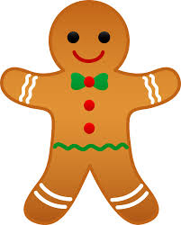





**Additional Information**

*Thank you to our party volunteers! We had a great time trying new hands-on stations and the students really enjoyed them.

*Thank you for all of the donations for our party/stations! We appreciate your support!

*Have a safe and Happy New Year!

.

1. place

2. barge

3. trace

4. ice

5. bulge

6. badge

7. space

8. range

9. mice

10. cage

11. mule

12. huge

13. out

14. wash

15. saw

**Spelling List for**

**the week of January 9th.**

**Soft c & Soft g**

-Reading/Writing-

**Unit 2.2-Week 2**

**Comprehension Strategy:** make predictions

**Comprehension Skill:** plot: problem and solution

**Vocabulary Strategy:** suffixes: ly, ful

**Writing Traits:** organization, ideas

**Grammar:** singular and plural nouns

**Structural Analysis:** cvce syllables

**Mechanics:** commas in a series

**Concept Map:** Double Bubble Map

*Unit Assessment

-Math-

**Unit 4-Double Digit Addition & Subtraction**

We will continue to add using the break apart strategy with double digit numbers after the holiday break.

-**Social Studies/**Science-

We will begin the States of Matter science unit after break.

**Homework**

**\*\*No Homework\*\***

*Students are welcome to log on to Dreambox, X-tra Math, Raz-kidz, or read for fun over break.

**1. zoo**

**2. food**

**3. who**

**4. moon**

**5. book**

**6. soon**

**7. stood**

**8. good**

**9. look**

**10. foot**

**11. noon**

**12. room**

**13. took**

**14. you**

**15. could**

**16.should**

**This week in Review**