

###### **December 2, 2016**

##### Mrs. Maley - Mrs. Pater-Mrs. Terenzi-Ms. Versteegden

**Upcoming Dates**

**What’s Happening In 2nd Grade**

**December 15th**

Skating at the Rink

**December 16th**

Parent’s Night Out

**December 23rd –January 3rd**

Winter Break

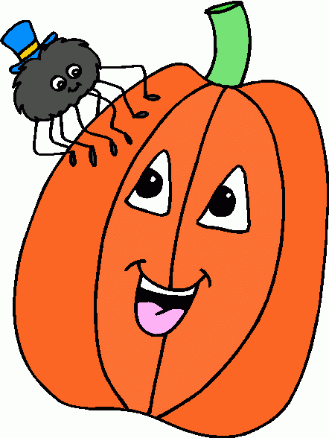

**December 2nd**

Scrip Sale Ends

**December 6th**

GPTO Meeting 7pm

**December 7th-9th**

Santa Shop

**December 9th**

Holiday Night

**1. job**

**2. pot**

**3. nod**

**4. top**

**5. not**

**6.dot**

**7. fox**

**8. mop**

**9. spot**

**10. hop**

**11. pop**

**12. drop**

**13. on**

**14. box**

**15.pocket**

**16.hospital**

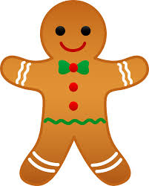





**Additional Information**

*Now that we are in the 2nd card marking, there will be an additional section added to the weekly Fluency Homework. On the front side will be the **Pop Words** (word fluency) and the back will have a **passage**/story (fluency in context). Please continue to assist your child in completing this weekly homework activity. The weekly practice will really pay off by the end of the year and you will be amazed at how much they have grown! Thank you so much!

**Homework**

\***Math Review Packet**

Due: December 7th

**\*Reading Fluency Activity**

Due: December 9th

1. I’ll

2. we’ve

3. don’t

4. you’re

5. isn’t

6. didn’t

7. you’ll

8. I’ve

9. hasn’t

10. we’ll

11. can’t

12. she’ll

13. wasn’t

14. that’s

15. doesn’t

16. aren’t

-Reading/Writing-

**Unit 2- Week 1**

**Comprehension Strategy:** make predictions

**Comprehension Skill:** character, setting, plot

**Vocabulary Strategy:** prefixes: re-, un-, dis-

**Writing Traits:** organization, ideas

**Grammar:** nouns

**Structural Analysis:** -ed, -ing

**Mechanics:** commas in a series

**Concept Map:** Double Bubble Map

-Math-

**Unit 3-Basic Addition and Subtraction**

Vocabulary: addend, sum, doubles, doubles +1, number line, count up, count back, fact family, related facts, number bonds, friends of ten, making a ten to add

-**Social Studies/**Science-

**Social Studies-Discovering Our Past**

Vocabulary: culture, heritage, immigrant, explorers, colonists, pilgrims

**Spelling List for**

**Next Week**

**Contractions**

**This week in Review**