

###### **December 9, 2016**

##### Mrs. Maley - Mrs. Pater-Mrs. Terenzi-Ms. Versteegden

**Upcoming Dates**

**What’s Happening In 2nd Grade**

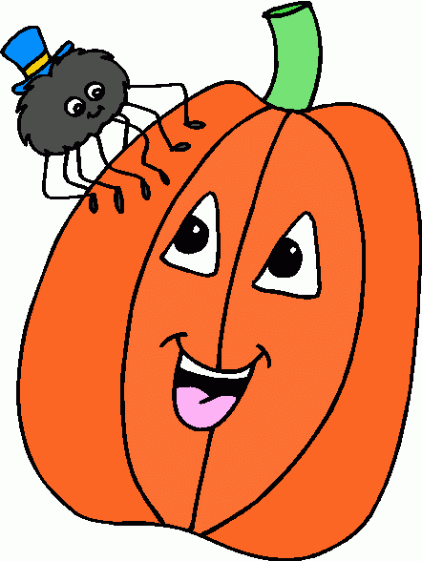

**December 16th**

Parent’s Night Out

**December 23rd –January 3rd**

Winter Break

**December 7th-9th**

Santa Shop

**December 9th**

Holiday Night

**December 13th**

Recycling Assembly

GPTO Meeting 7pm

**December 15th**

Skating at the Rink

**1. job**

**2. pot**

**3. nod**

**4. top**

**5. not**

**6.dot**

**7. fox**

**8. mop**

**9. spot**

**10. hop**

**11. pop**

**12. drop**

**13. on**

**14. box**

**15.pocket**

**16.hospital**

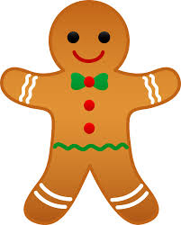

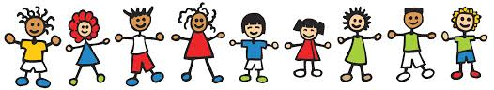

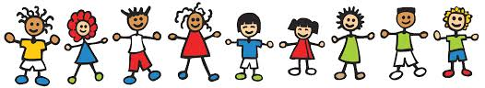

**Additional Information**

*An informational note is included in today’s Friday Folders regarding our **holiday stations**. Please complete and return the bottom portion if you are able to donate an item or volunteer.

*Please be sure your child has boots, hats, and gloves for the weather.

*Graebner is collecting canned and boxed food items for Kiwanis.

-Reading/Writing-

**Unit 2.1-Week 2**

**Comprehension Strategy:** make predictions

**Comprehension Skill:** character, setting, plot

**Vocabulary Strategy:** prefixes: re-, un-, dis-

**Writing Traits:** organization, ideas

**Grammar:** nouns

**Structural Analysis:** -ed, -ing

**Mechanics:** commas in a series

**Concept Map:** Double Bubble Map

*Unit Assessments

-Math-

We are wrapping up **Unit 3-Basic Addition and Subtraction**. Our next unit of study will be **Two-Digit Addition**.

-**Social Studies/**Science-

**Social Studies-Discovering Our Past**

Vocabulary: culture, heritage, immigrant, explorers, colonists, pilgrims, pioneers

Next week we will complete the social studies unit. In January, we will begin **States of Matter** in science.

**Homework**

\***Social Studies Review Packet**

Due: December 13th

Test Date: December 16th

**\*Reading Fluency Activity**

Due: December 16th

**1. zoo**

**2. food**

**3. who**

**4. moon**

**5. book**

**6. soon**

**7. stood**

**8. good**

**9. look**

**10. foot**

**11. noon**

**12. room**

**13. took**

**14. you**

**15. could**

**16.should**

**Spelling List for**

**Next Week**

**-oo sounds**

**This week in Review**