

###### **February 10, 2017**

##### Mrs. Maley - Mrs. Pater-Mrs. Terenzi-Ms. Versteegden



**Upcoming Dates**

**What’s Happening In 2nd Grade**

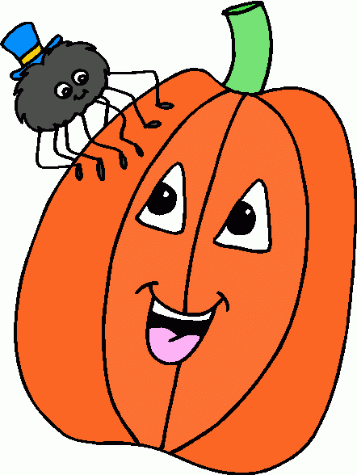

**1. job**

**2. pot**

**3. nod**

**4. top**

**5. not**

**6.dot**

**7. fox**

**8. mop**

**9. spot**

**10. hop**

**11. pop**

**12. drop**

**13. on**

**14. box**

**15.pocket**

**16.hospital**

**January 30th-February 10th**

Valentine Candy Gram Sale

**February 20th-February 24th**

Winter Break

No School



**February 14th**

Valentine’s Party

9-11

**February 15th**

2nd Grade Concert 6:30



**Spelling List for Next Week:**

**Suffixes –y & -ly**

**Additional Information**

*Thank you parents for all of the Valentine’s Party supplies. The students will really enjoy our 2nd grade progressive party!

*We are running low on **Kleenex** and **Clorox Wipes** if you are able to send in any donations. Thank you so much for your support!

1. sticky

2. slowly

3. very

4. quietly

5. cloudy

6. happy

7. loudly

8. heavy

9. lucky

10. stormy

11. many

12. clearly

13. angry

14. chilly

15. quickly

**Homework**

**\*Valentine’s Box**

**Due: February 10th**

**\*Pop Words/Fluency 4.1**

Due Date: Friday, February 17th

**\*Science Review Packet**

Due Date: Monday, February 13th

**\*Science Test on Wed, February 15th**

-Reading/Writing-

**Unit 2-Week 4**

**Comprehension Strategy:** reread

**Comprehension Skill:** main topic & key details

**Vocabulary Strategy:** multiple meaning words

**Writing Traits:** word choice

**Grammar:** plural nouns –s, -es, irregular plurals

**Structural Analysis:** suffixes: -ful, -less

**Mechanics:** abbreviations

**Concept Map:** Tree Map

-Math-

**Unit 4-Double Digit Subtraction**

*completed pre-test

*practiced break apart subtraction strategy

**Vocabulary:** subtract, difference, regroup, digit, count back, number line, break apart, bar model

-Social Studies**/Science**-

*investigated chemical and physical changes in matter

*compared subtances and mixtures

**Vocabulary:** matter, mass, solid, liquid, gas, density, buoyancy, substance, and mixture

**\*Throughout the month of February, all students will participate in Black History Month and Cultural Diversity activities in Art, ISM, and the classroom.**

**This week in Review**