

###### **February 17, 2017**

##### Mrs. Maley - Mrs. Pater-Mrs. Terenzi-Ms. Versteegden



**Upcoming Dates**

**What’s Happening In 2nd Grade**

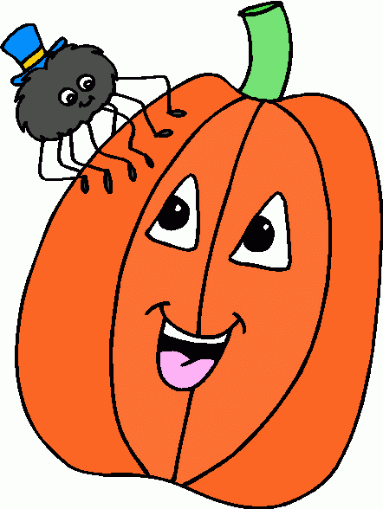

**1. job**

**2. pot**

**3. nod**

**4. top**

**5. not**

**6.dot**

**7. fox**

**8. mop**

**9. spot**

**10. hop**

**11. pop**

**12. drop**

**13. on**

**14. box**

**15.pocket**

**16.hospital**

**February 20th-February 24th**

Winter Break

No School

**February 17th**

Chipotle Night

**March 10th**

Author Visit

Bryan Chick

**March 15th**

Kindergarten Round Up

**March 21st-23rd**

District Art Show **March 30th**

Spring Pictures

**March 31st**

Half Day, End of 3rd Marking Period





**Additional Information**

*Congratulations to our singing stars. They did an amazing job at the music concert!

*Thank you so much for the donations of Clorox Wipes and Kleenex!

1. plane

2. plain

3. tail

4. tale

5. rode

6. raod

7. hole

8. whole

9. to

10. too

11. two

12. their

13. there

14. they’re

15. threw

**Spelling List for the Week of February 27th-Homophones**

-Reading/Writing-

*expository animal texts

*explored informational text features

**Concept Map:** Tree Map

-Math-

**Unit 4-Double Digit Subtraction**

*practiced break apart subtraction strategy

*regrouped to solve subtraction equations

**Vocabulary:** subtract, difference, regroup, digit, count back, number line, break apart, bar model, minuend, subtrahend, how many more, compare

-Social Studies**/Science**-

*completed **States of Matter** **Unit**

*began **Fluid Earth Unit**

**Vocabulary**: water sources, surface, sky, underground, pond, sleet, hail, glacier, rain, lake, well, river, frost, stream, dew, snow, ocean, ice, spring

**\*Throughout the month of February, all students will participate in Black History Month and Cultural Diversity activities in Art, ISM, and the classroom.**

**Homework**

**No Homework over Winter Break! Enjoy your time off with family and friends!**

Feel free to work on Dreambox, X-tra Math, and Raz-Kids.

**This week in Review**