

###### **February 3, 2017**

##### Mrs. Maley - Mrs. Pater-Mrs. Terenzi-Ms. Versteegden



**Upcoming Dates**

**What’s Happening In 2nd Grade**



**1. job**

**2. pot**

**3. nod**

**4. top**

**5. not**

**6.dot**

**7. fox**

**8. mop**

**9. spot**

**10. hop**

**11. pop**

**12. drop**

**13. on**

**14. box**

**15.pocket**

**16.hospital**

**February 3rd**

Daddy Daughter Dance

**February 9th**

Spring Conferences

**February 14th**

Valentine’s Party 9-11

**February 15th**

2nd Grade Concert 6:30

**January 30th-February 10th**

Valentine Candy Gram Sale

**February 20th-February 24th**

Winter Break

No School

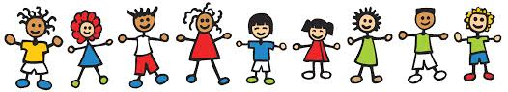

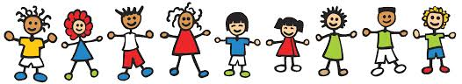

**\*Throughout the month of February, all students will participate in Black History Month and Cultural Diversity activities in Art, ISM, and the classroom.**

**Homework**

**\*Valentine’s Box**

**Due: February 10th**

**\*Pop Words/Fluency 3.5**

Due Date: Friday, February 10th

**\*Abbreviations/Common & Proper Noun Practice Sheet**

Due Date: Monday, January 30th

-Reading/Writing-

**\*Groundhog’s Day Activities**

**Unit 2-Week 3**

**Comprehension Strategy:** make predictions

**Comprehension Skill:** main topic & key details

**Vocabulary Strategy:** suffixes –ly, -ful

**Writing Traits:** organization, complete paragraph

**Grammar:** common & proper nouns

**Structural Analysis:** prefixes re-, un-, dis-

**Mechanics:** capital letters-proper nouns

**Concept Map:** Double Bubble Map & Tree Map

-Math-

**Unit 4-Double Digit Addition & Subtraction**

We completed unit 4 on Friday. Our next unit of study is

**Unit 5-Double Digit Subtraction.**

-Social Studies**/Science**-

*explored the properties of gases

*investigated chemical and physical changes

*reviewed the placement of atoms in each state of matter

**Vocabulary:** matter, mass, solid, liquid, gas, density, buoyancy, substance, and mixture

**Additional Information**

*Please be sure to read over the **Fluency Homework Note** attached to theis week’s Pop Words. Many students have improved in their rate of reading (speed) and are ready to begin focusing on **using expression**. This is an important 2nd grade skill. It marks the transition between learning to read and reading to learn.

1. scratch

2. scrape

3. spring

4. throne

5. stripe

6. strange

7. shred

8. shrub

9. splash

10. split

11. catch

12. sting

13. far

14. flower

15. until

**Spelling List for Next Week:**

**Complex Digraphs**

**This week in Review**