

###### **January 20, 2017**

##### Mrs. Maley - Mrs. Pater-Mrs. Terenzi-Ms. Versteegden

**Upcoming Dates**

**What’s Happening In 2nd Grade**

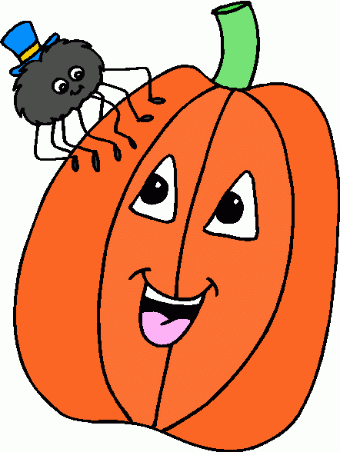

**January 23rd-27th**

**The Great Kindness Challenge**

**Spirt Week**

**Monday-Hats Off to Kindness Day**

-Wear a hat

**Tuesday-Graebner Kids Are Kind Day**

-Wear Graebner gear

**Wednesday-Dream of Kindness in our** **Community Day**

-Wear pajamas

**Thursday-Peace, Love and Kindness Day**

-Dress like a “peace”ful person or wear red or pink for love

**Friday-We’re Crazy for Kindness**

-Wear crazy hair

**January 31st**

Piston’s Assembly

**February 3rd**

Daddy Daughter Dance

**January 30th-February 10th**

Valentine Candy Gram Sale

**February 20th-February 24th**

Winter Break

No School

**1. job**

**2. pot**

**3. nod**

**4. top**

**5. not**

**6.dot**

**7. fox**

**8. mop**

**9. spot**

**10. hop**

**11. pop**

**12. drop**

**13. on**

**14. box**

**15.pocket**

**16.hospital**

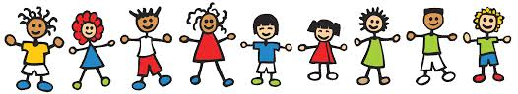

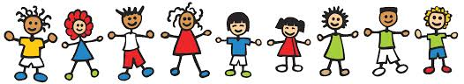

**Homework**

*Pop Words/Fluency 3.3

Due Date: Friday, January 27th

*Math/Science Sheet

Due Date: Monday, January 23rd

**Spelling List for Next Week:**

**Compound Words**

1. bathtub

2. bedtime

3. myself

4. someone

5. maybe

6. rainbow

7. upon

8. anyone

9. without

10. cannot

11. pancake

12. airplane

13. ladybug

14. sweatshirt

15. downstairs

**Additional Information**

*Just a reminder that for the 2nd card marking, **reports cards will be online only**. If you do not have a powerschool account, please see the office as soon as possible to create an account.

-Reading/Writing-

This week we continued completing district and school assessments in the areas of reading and writing.

-Math-

**Unit 4-Double Digit Addition & Subtraction**

We continued adding with regrouping or carrying over.

**Vocabulary**: add, sum, equation, making ten, decompose, break apart, compensation, and communative property of addition

-Social Studies**/Science**-

We discussed density and buoyancy. We will be completing an experiment comparing the relative densities of various liquids.

**Vocabulary:** matter, mass, solid, liquid, gas, density, buoyancy, substance, and mixture

**This week in Review**

**1. zoo**

**2. food**

**3. who**

**4. moon**

**5. book**

**6. soon**

**7. stood**

**8. good**

**9. look**

**10. foot**

**11. noon**

**12. room**

**13. took**

**14. you**

**15. could**

**16.should**