

###### **January 6, 2017**

##### Mrs. Maley - Mrs. Pater-Mrs. Terenzi-Ms. Versteegden

**Upcoming Dates**

**What’s Happening In 2nd Grade**

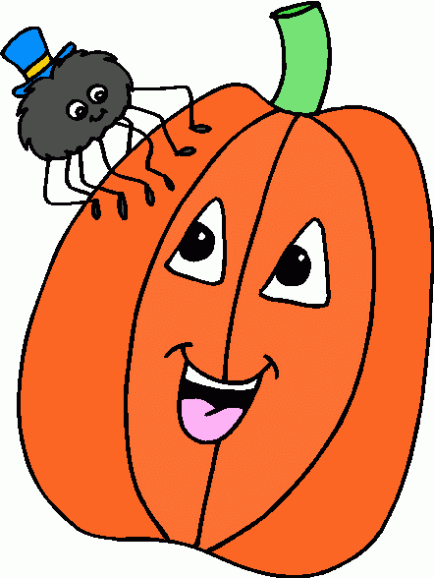

**January 10th**

GPTO Meeting

**January 16th**

Dr. MLK Jr. Observance-

NO School

**January 19th and 20th**

½ Days

End of Quarter 2

**1. job**

**2. pot**

**3. nod**

**4. top**

**5. not**

**6.dot**

**7. fox**

**8. mop**

**9. spot**

**10. hop**

**11. pop**

**12. drop**

**13. on**

**14. box**

**15.pocket**

**16.hospital**

**January 31st**

Piston’s Assembly

**February 3rd**

Daddy Daughter Dance

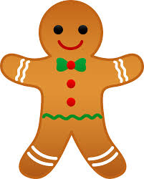

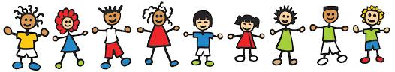

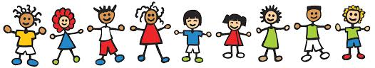

**Homework**

*Pop Words/Fluency 3.1

Due Date: Friday, January 13th

*Math Practice Sheet

Due Date: Monday, January 9th

**Spelling List for**

**next week:**

**Soft c & Soft g**

-Reading/Writing-

**Happy New Year to all students and families!**

This week we discussed goal setting and making resoultions for a great 2017. We read several New Year’s stories, completed a New Year’s reading and comprehension activity, and began a special New Year’s project.

-Math-

**Unit 4-Double Digit Addition & Subtraction**

We reviewed adding with the break apart strategy. We introduced and practiced using a new addition strategy called compensation.

**Vocabulary**: add, sum, equation, making ten, decompose, break apart, compensation, and communative property of addition

-Social Studies**/Science**-

We began the States of Matter science unit. We discussed matter and mass, as well as identified the characteristics and properties of solids.

**Vocabulary:** matter, mass, solid, liquid, gas, substance, and mixture

**Additional Information**

*We began our winter NWEA computerized testing this week in reading and math.

*Next week we will begin indiviual reading assessments for report cards. (Rigby & DIBELS)

1. place

2. barge

3. trace

4. ice

5. bulge

6. badge

7. space

8. range

9. mice

10. cage

11. mule

12. huge

13. out

14. wash

15. saw

**1. zoo**

**2. food**

**3. who**

**4. moon**

**5. book**

**6. soon**

**7. stood**

**8. good**

**9. look**

**10. foot**

**11. noon**

**12. room**

**13. took**

**14. you**

**15. could**

**16.should**

**This week in Review**