

###### **June 9, 2017**

##### Mrs. Maley-Mrs. Pater-Mrs. Terenzi-Ms. Versteegden

**Upcoming Dates**

**What’s Happening In 2nd Grade**



**June 9th**

School Carnival

**June 13th**

2nd Grade Picnic

11:15-1:00

**\*Please bring your yearbook for autographs!**

GPTO Meeting

**June 15th**

Last Day of School

Half Day 11:32 Dismissal

**1. job**

**2. pot**

**3. nod**

**4. top**

**5. not**

**6.dot**

**7. fox**

**8. mop**

**9. spot**

**10. hop**

**11. pop**

**12. drop**

**13. on**

**14. box**

**15.pocket**

**16.hospital**

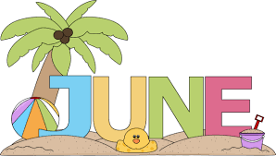

**This Week in Review**



**Additional Information**

*Thank you for all of your generous donations for the Carnival Basket. I’m sure it will be wonderful! We hope to see many of you at the carnival tonight.

-**Reading/Writing**-

*2nd Grade Memory Books

*End of Year Testing and Make Ups

-**Math**-

*We reviewed concepts learned throughout the year. *We completed our end of the year testing and NWEA computerized testing.

-**Social Studies/Science**-

*We completed our Communities unit. We began a short unit on Living Things-Plants. Next week, we will discuss Civics and Government.

**Homework**

No Homework!

Next week, we will have two different Spelling Bees.

On Monday, each class will have a Spelling Bee to determine the top 5 spellers and a class winner.

On Tuesday, the top 5 spellers from each class will participate in a Spelling Bee to determine a 2nd Grade Spelling Bee Champion. A review list of all spelling words is in Friday Folders today.

**Spelling Next Week**