

###### **March 17, 2017**

##### Mrs. Maley-Mrs. Pater-Mrs. Terenzi-Ms. Versteegden

**Upcoming Dates**

**What’s Happening In 2nd Grade**

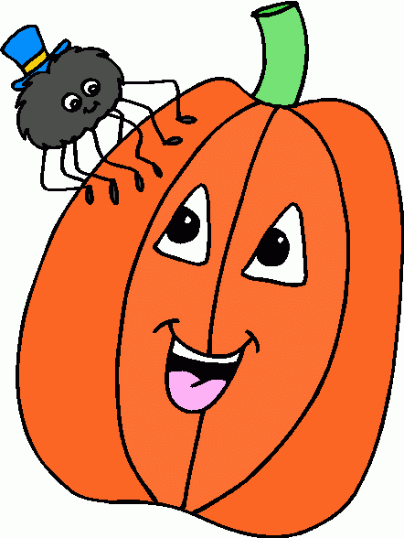

**March 21st-23rd**

District Art Show

**March 29th**

Music Concert

1st-6:30

**March 30th**

Spring Pictures

**March 31st**

Half Day, End of 3rd Marking Period

**April 3rd–7th**

Spring Break

**1. job**

**2. pot**

**3. nod**

**4. top**

**5. not**

**6.dot**

**7. fox**

**8. mop**

**9. spot**

**10. hop**

**11. pop**

**12. drop**

**13. on**

**14. box**

**15.pocket**

**16.hospital**

**April 4th**

Hungry Howie’s Night

**April 11th**

Cookie Dough Orders Due

**April 14th**

No School

**April 17th-21st**

Garden Club Flower Sale





**Homework**

**\*Fluency/Reading Skill**

Due: Friday, March 24th

**\*Science Review Sheet**

Due: Monday, March 20th

Test Date: Friday, March 24th

-Reading/Writing-

**Poetry Unit**

**Vocabulary: rhythm, simile, onomatopoeia, free verse, repetition, alliteration, metaphor, couplet, stanza, simile**

**Unit 3.1**

**Comprehension Strategy:** reread

**Comprehension Skill:** author’s purpose

**Vocabulary Strategy:** similes

**Writing Traits:** organization

**Grammar:** action verbs

**Structural Analysis:** contractions: ‘s, ‘re, ‘ll, ‘ve

**Mechanics:** abbreviations

**Concept Map:** Tree Map

**Genre**: Expository Text

-Math-

**Unit-7 Money**

*identified and counted coins

**Vocabulary:** money, cent, penny, nickel, dime, quarter, half-dollar, dollar, decimal point

-Social Studies**/Science**-

**Water on Earth**

*identified where water sources are found on Earth

**Vocabulary**: water sources, surface, sky, underground, pond, sleet, hail, glacier, rain, lake, well, river, frost, stream, dew, snow, ocean, ice, spring

**This week in Review**

**March Is Reading Month**

*Throughout the month of March, students will enjoy many exciting activities centered around reading. Please review the calendar so your child doesn’t miss out on the fun! There is a **Home Connection Recording Sheet** that should be completed throughout the month focusing on reading different genres.

1. told

2. most

3. float

4. coat

5. toast

6. grow

7. mow

8. show

9. Joe

10. toe

11. light

12. mind

13. only

14. our

15. who

**Spelling List for Next Week**

**Long o**