

###### **May 19, 2017**

##### Mrs. Maley-Mrs. Pater-Mrs. Terenzi-Ms. Versteegden

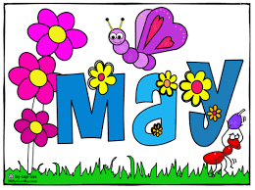

**Upcoming Dates**

**What’s Happening In 2nd Grade**

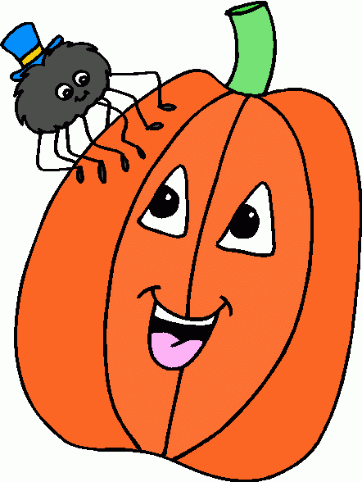

**May 26th & 29th**

No School

**June 7th**

Field Day

**June 9th**

School Carnival

**June 15th**

Last Day of School

Half Day

**1. job**

**2. pot**

**3. nod**

**4. top**

**5. not**

**6.dot**

**7. fox**

**8. mop**

**9. spot**

**10. hop**

**11. pop**

**12. drop**

**13. on**

**14. box**

**15.pocket**

**16.hospital**

**This Week in Review**



**Additional Information**

*Please make sure your child is wearing school approriate attire.

* Close-toe shoes or boots must be worn (no flip-flops or sandals for safety reasons.)

*Shorts, skorts, or jumpers must be knee length.

*Please send a jacket/hoodie to school with your child on chilly mornings. Students must wear a jacket if it is below 60 degrees and our first recess is at 11:30 in the morning.

**Homework**

**\*Animal Report Research Activity**

**Due: Monday, May 22nd**

**\*Math Review Packet**

**Due: Thursday, May 25th**

-Reading/Writing-

**Unit 3.4 Wild Weather**

**Comprehension Strategy:** ask and answer questions

**Comprehension Skill:** main idea and key details

**Vocabulary Strategy:** antonyms

**Writing Traits:** organization, voice, and opinion writing

**Grammar:** verbs-have, has, had

**Structural Analysis:** plurals –s, -es, -ies

**Mechanics:** book titles

**Concept Map:** Multi-Flow Map

**Genre**: expository text

Unit Assessments & District Opinion Writing Assessment

-Math-

*We completed our mini graphing unit. We will continue working with multiplication and division, as well as reviewing for our end of the year testing.

**Vocabulary:** multiply, factor, product, equal groups, repeated addition, array, times, repeated subtration, quotient, divisor, dividend

-Social Studies**/Science**-

**Communities**

*We discussed different characteristics of urban, suburban, and rural communities.

1. sound

2. mound

3. cloud

4. shout

5. pound

6. clown

7. brown

8. crown

9. howl

10. growl

11. chair

12. where

13. been

14. myself

15. pushed

**Spelling List for Next Week:**

**-ou, -ow words**