

###### **May 25, 2017**

##### Mrs. Maley-Mrs. Pater-Mrs. Terenzi-Ms. Versteegden

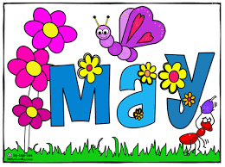

**Upcoming Dates**

**What’s Happening In 2nd Grade**

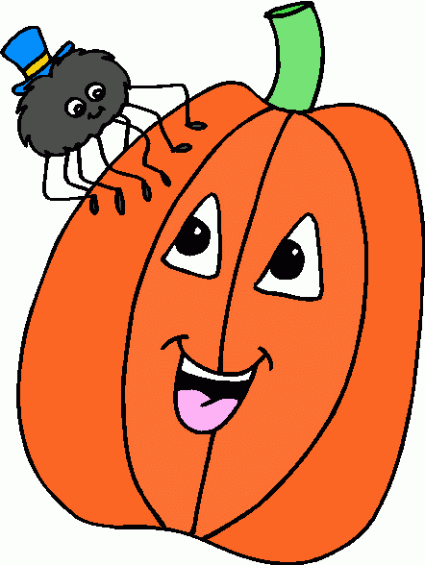

**May 26th & 29th**

No School

**June 7th**

Field Day

**June 9th**

School Carnival

**June 15th**

Last Day of School

Half Day

**1. job**

**2. pot**

**3. nod**

**4. top**

**5. not**

**6.dot**

**7. fox**

**8. mop**

**9. spot**

**10. hop**

**11. pop**

**12. drop**

**13. on**

**14. box**

**15.pocket**

**16.hospital**

**This Week in Review**

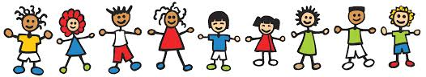

-Reading/Writing-

**Unit 3.5 How Do you Express Yourself?**

**Comprehension Strategy:** ask and answer questions

**Comprehension Skill:** main idea and key details

**Vocabulary Strategy:** prefixes re-, dis-

**Writing:** Animal Reports

**Grammar:** combining and rearranging sentences

**Structural Analysis:** plurals –s, -es, -ies

**Mechanics:** book titles

**Concept Map:** Multi-Flow Map

**Genre**: expository text

-Math-

**Multiplication & Division**

*We continued working with multiplication and division, as well as reviewing for our end of the year testing.

**Vocabulary:** multiply, factor, product, equal groups, repeated addition, array, times, repeated subtration, quotient, divisor, dividend

-Social Studies**/Science**-

**Communities**

*We discussed and sorted characteristics of urban, suburban, and rural communities. We also identified traits of good citizens.

**Additional Information**

*Please make sure your child is wearing school approriate attire.

* Close-toe shoes or boots must be worn (no flip-flops or sandals for safety reasons.)

*Shorts, skorts, or jumpers must be knee length.

*Please send a jacket/hoodie to school with your child on chilly mornings.

*Students must wear a jacket if it is below 60 degrees and our first recess is at 11:30 in the morning.

*Donations are still needed for our carnival basket. The theme is Detroit sports. Thank you!

**Homework**

Enjoy the long weekend with family and friends.

**No Homework!**

1. soil

2. broil

3. moist

4. point

5. toil

6. oil

7. toy

8. joy

9. coin

10. noise

11. crown

12. mound

13. I’ll

14. laugh

15. maybe

**Spelling List for Next Week:**

**-oy, -oi words**