

###### **November 11, 2016**

##### Mrs. Maley - Mrs. Pater-Mrs. Terenzi-Ms. Versteegden

**Upcoming Dates**

**What’s Happening In 2nd Grade**

**November 17th**

Half Day

Conferences

12:30-8

**November 23rd-25th**

No School

Thanksgiving Recess

**November 11th**

Veteran’s Day

Scrip Sale Begins

**November 14th**

Book Fair Week

**November 16th**

Conferences

5-8

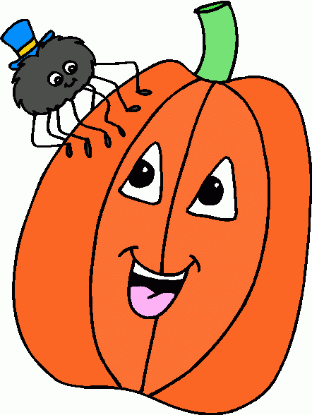

**1. job**

**2. pot**

**3. nod**

**4. top**

**5. not**

**6.dot**

**7. fox**

**8. mop**

**9. spot**

**10. hop**

**11. pop**

**12. drop**

**13. on**

**14. box**

**15.pocket**

**16.hospital**





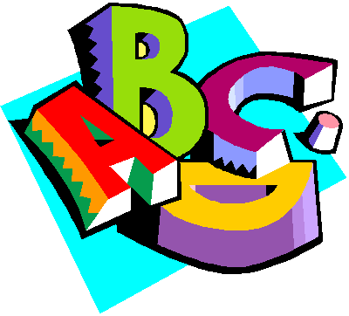

**Additional Information**

*We are so excited to meet with each family next week at conferences. We will try our best to be mindful of the schedule. We know it is a short amount of time, but we must be respectful of the 15 minute time frame allotted for each conference. Thank you in advance for your cooperation!

1. liked

2. batted

3. joined

4. baked

5. stopped

6. shouted

7. chased

8. stepped

9. waited

10. closed

11. pinned

12. named

13. missed

14. flipped

15. decided

16. chewed

-Reading/Writing-

**Unit 1- Week 4 (continued)**

**Comprehension Strategy:** ask and answer questions

**Comprehension Skill:** key details, use photos

**Vocabulary Strategy:** root words

**Writing Traits:** organization, complete paragraph

**Grammar:** predicates

**Structural Analysis:** -ed, -ing, sounds of “ed”

**Mechanics:** commas with sequence words

**Concept Map:** Bubble Map

*End of Unit Assessment

-Math-

**Unit 3-Basic Addition and Subtraction**

Vocabulary: addend, sum, doubles, doubles +1, number line, count up, count back, fact family, related facts, number bonds, friends of ten, making a ten to add

-**Social Studies/**Science-

**Social Studies-Citizenship and Voting, Veteran’s Day**

Vocabulary: citizen, rights and responsibilities, vote, United States of America, veteran

**Homework**

**\*Fluency Practice-**

**Pop Words 2.2**

Due: Friday, November 18th

\***Heritage Doll Project**

Due: Monday, November 21st

**Spelling List for**

**Next Week**

**Words with “ed” Ending**

**This week in Review**