

###### **November 18, 2016**

##### Mrs. Maley - Mrs. Pater-Mrs. Terenzi-Ms. Versteegden

**Upcoming Dates**

**What’s Happening In 2nd Grade**

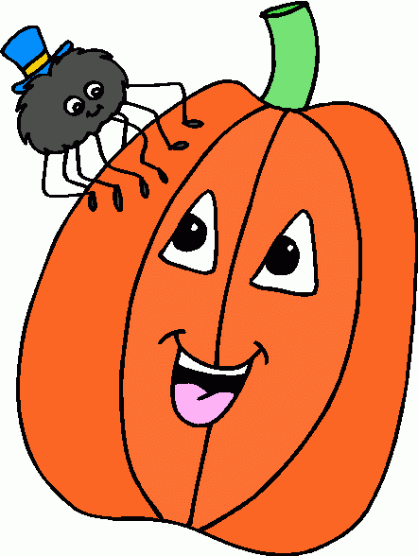

**December 9th**

Holiday Night

**December 16th**

Parent’s Night Out

**December 23rd –January 3rd**

Winter Break

**November 23rd-25th**

No School

Thanksgiving Recess

**December 2nd**

Scrip Sale Ends

**December 6th**

GPTO Meeting 7pm

**December 7th-9th**

Santa Shop

**1. job**

**2. pot**

**3. nod**

**4. top**

**5. not**

**6.dot**

**7. fox**

**8. mop**

**9. spot**

**10. hop**

**11. pop**

**12. drop**

**13. on**

**14. box**

**15.pocket**

**16.hospital**

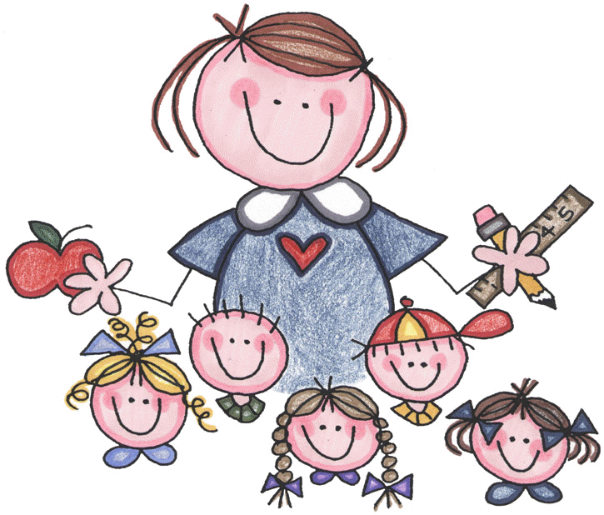



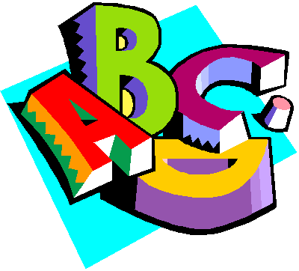

**Additional Information**

*It was great meeting with each family during conferences this week.

*There will be no newsletter or homework assignments next week due to the short week. Enjoy this special time with your family!

**Happy Thanksgiving!**

**Homework**

\***Heritage Doll Project**

Due: Monday, November 21st

**(sent home last week)**

1. dishes

2. dresses

3. bells

4. boxes

5. beaches

6. days

7. bikes

8. wishes

9. things

10. names

11. children

12. foxes

13. kisses

14. grapes

15. classes

16. giraffes

-Reading/Writing-

**Unit 1- Week 5**

**Comprehension Strategy:** ask and answer questions

**Comprehension Skill:** key details

**Vocabulary Strategy:** inflectional endings: s, es, ed, ing

**Writing Traits:** sentence fluency

**Grammar:** expanding and combining sentences

**Structural Analysis:** possessives

**Mechanics:** quotation marks

**Concept Map:** Bubble Map

-Math-

**Unit 3-Basic Addition and Subtraction**

Vocabulary: addend, sum, doubles, doubles +1, number line, count up, count back, fact family, related facts, number bonds, friends of ten, making a ten to add

-**Social Studies/**Science-

**Social Studies-Discovering Our Past**

Vocabulary: culture, heritage, immigrant, explorers, colonists, pilgrims

**Spelling List for**

**Next Week**

**Words with –s or -es**

**This week in Review**