

###### **November 4, 2016**

##### Mrs. Maley - Mrs. Pater-Mrs. Terenzi-Ms. Versteegden

**Upcoming Dates**

**What’s Happening In 2nd Grade**

**November 14th**

Book Fair Week

**November 16th**

Conferences

5-8

**November 17th**

Half Day

Conferences

12:30-8

**November 23rd -25th**

No School

Thanksgiving Recess

**November 4th**

End of Quarter 1

**November 7th**

McTeacher Night

Lakeside McDonalds 4-7

**November 8th**

No School-Voting Day

**November 11th**

Veteran’s Day

Scrip Sale Begins



**1. job**

**2. pot**

**3. nod**

**4. top**

**5. not**

**6.dot**

**7. fox**

**8. mop**

**9. spot**

**10. hop**

**11. pop**

**12. drop**

**13. on**

**14. box**

**15.pocket**

**16.hospital**





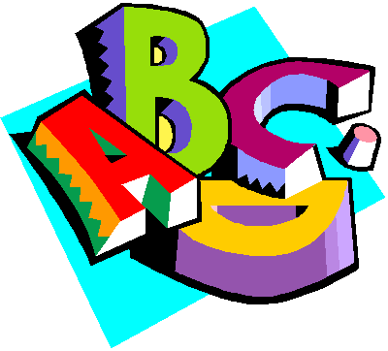

1. mule

2. fuse

3. plum

4. use

5. dug

6. cub

7. hum

8. huge

9. must

10. fun

Review Words

11. rope

12. nose

High Frequency Words

13. look

14. yes

15. their

**Additional Information**

*The first marking period ends today. Please be sure to review your child’s **Missing Assignment Report**, sign and return it to school. Report cards will be given out at conferences.

\***Thank you** for all of the Halloween donations and party volunteers! The students really enjoyed the crafts, treats and parade!

-Reading/Writing-

**Unit 1- Week 4**

**Comprehension Strategy:** ask and answer questions

**Comprehension Skill:** key details, use photos

**Vocabulary Strategy:** root words

**Writing Traits:** organization, complete paragraph

**Grammar:** predicates

**Structural Analysis:** -ed, -ing, sounds of “ed”

**Mechanics:** commas with sequence words

**Concept Map:** Bubble Map

*District Narrative Writing Assessment-Fairy Tale

-Math-

**Unit 3-Basic Addition and Subtraction**

Vocabulary: addend, sum, doubles, doubles +1, number line, count up, count back, fact family, related facts

-**Social Studies/**Science-

**Social Studies-Citizenship and Voting**

Vocabulary: citizen, rights and responsibilities, vote, United States of America

**Homework**

**\*Fluency Practice-**

**Pop Words 2.1**

Due: Friday, November 11th

\***Doubles + 1 Math Activity**

Due: Monday, November 7th

**Spelling List for**

**Next Week-**

**Short u & Long u**

**This week in Review**