

###### **October 14, 2016**

##### Mrs. Maley - Mrs. Pater-Mrs. Terenzi-Ms. Versteegden

**Upcoming Dates**

**What’s Happening In 2nd Grade**

**October 18th**

Donuts with Dad A-L

**October 19th**

Donuts with Dad M-Z

**October 21st**

Spirit Wear Sale

GPTO Trunk or Treat

**October 31st**

Halloween Party, 9-11

Half Day 11:32

**November 8th**

No School-Voting Day

**November 11th**

Veteran’s Day

Scrip Sale Begins

**November 14th**

Book Fair Week

**November 16th**

Conferences

5-8

**November 17th**

Half Day

Conferences

12:30-8

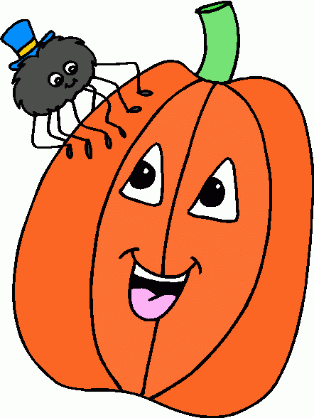

**1. job**

**2. pot**

**3. nod**

**4. top**

**5. not**

**6.dot**

**7. fox**

**8. mop**

**9. spot**

**10. hop**

**11. pop**

**12. drop**

**13. on**

**14. box**

**15.pocket**

**16.hospital**





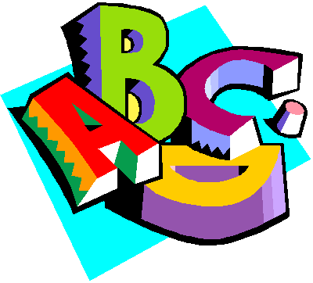

**Additional Information**

\***Progress Reports** are in your child’s Friday Folder today. Please review their report and then **sign and return** it to school on Monday.

*Please be sure your child completes any missing assignments that are attached to their Progress Report.

-Reading/Writing-

**Unit 1- Week 2 (continued)**

**Comprehension Strategy:** visualize

**Comprehension Skill:** character, setting, events

**Vocabulary Strategy:** root words

**Writing Traits:** ideas, organization, complete paragraph

**Grammar:** commands and exclamations

**Structural Analysis:** –s, -es

**Mechanics:** capitalization, punctuation with commands and exclamations

**Concept Map:** Flow Map

**Review:** singular and plurals nouns

*Completed Unit 1, Week 2 Assessment

-Math-

**Unit 2: Place Value to 1,000**

**Vocabulary:** ones, tens, hundreds, digit, word form, standard form, patterns, greater than, less than, 10 more, 10 less, 100 more, 100 less

-**Social Studies/**Science-

*Completed Social Studies Unit 1-Map Skils

*Next week we will begin Science Unit 1-What is a Scientist?

**Homework:**

**\*Math-Place Value Practice**

Due: Monday, October 17th

**\*Fluency Practice-**

**Pop Words 1.3**

Due: Friday, October 21st

**Spelling List for**

**Next Week**

**Short i, Long i**

1. did

2. fin

3. pick

4. line

5. pipe

6. tip

7. mix

8. five

9. side

10. hike

Review Words

11. cape

12. made

High Frequency Words

13. all

14. any

15. says

**This week in Review**