

###### **October 21, 2016**

##### Mrs. Maley - Mrs. Pater-Mrs. Terenzi-Ms. Versteegden

**Upcoming Dates**

**What’s Happening In 2nd Grade**

**October 21st**

Spirit Wear Sale

GPTO Trunk or Treat

**October 31st**

Halloween Party, 9-11

Half Day 11:32

**November 8th**

No School-Voting Day

**November 11th**

Veteran’s Day

Scrip Sale Begins

**November 14th**

Book Fair Week

**November 16th**

Conferences

5-8

**November 17th**

Half Day

Conferences

12:30-8

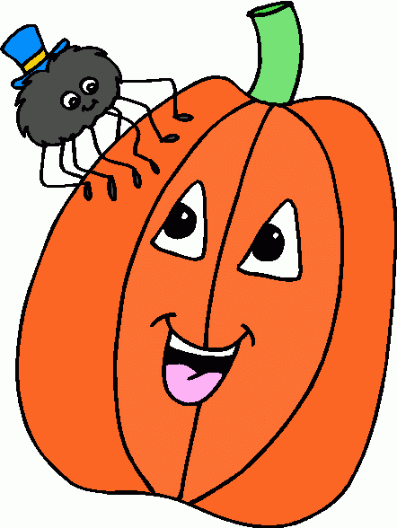

**1. job**

**2. pot**

**3. nod**

**4. top**

**5. not**

**6.dot**

**7. fox**

**8. mop**

**9. spot**

**10. hop**

**11. pop**

**12. drop**

**13. on**

**14. box**

**15.pocket**

**16.hospital**

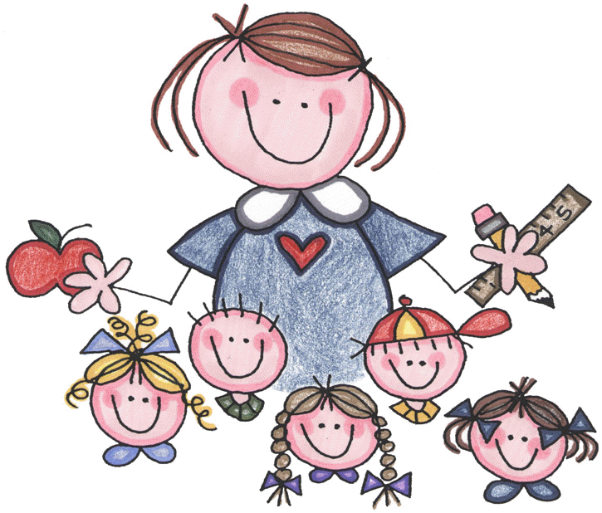



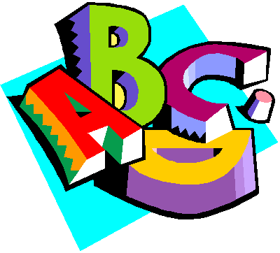

**Additional Information**

*Please be sure your child turned in their **Progress Report** and any **missing assignments**.

*Just a reminder to make sure your child is reading for 20 minutes each night and completing their **October Book It Calendar.** These can be turned in on November 1st .

1. spider

2. black

3. bat

4. pumpkin

5. trick

6. web

7. mask

8. skull

9. ghost

10. orange

11. candy

12. Halloween

-Reading/Writing-

**Unit 1- Week 3**

**Comprehension Strategy:** ask and answer question

**Comprehension Skill:** character, setting, events

**Vocabulary Strategy:** context clues

**Writing Traits:** word choice, complete paragraph

**Grammar:** subjects

**Structural Analysis:** closed syllables

**Mechanics:** letter punctuation: greeting, closing

**Concept Map:** Flow Map

**Review:** singular and plurals nouns, short a, long a

-Math-

**Unit 2: Place Value to 1,000**

**Vocabulary:** ones, tens, hundreds, digit, word form, standard form, patterns, greater than, less than, 10 more, 10 less, 100 more, 100 less

-**Social Studies/Science**-

*Map Skills-We demonstrated our learning by creating our own map using a rubric.

*Science Unit 1-What is a Scientist? What are tools scientists use?

**Homework:**

**\*Math-Place Value Review**

Due: Tuesday, October 25th

Test Date: Friday, October 28th

**\*Fluency Practice-**

**Pop Words 1.4**

Due: Friday, October 28th

**Spelling List for**

**Next Week-**

**October Words**

**This week in Review**