

###### **October 28, 2016**

##### Mrs. Maley - Mrs. Pater-Mrs. Terenzi-Ms. Versteegden

**Upcoming Dates**

**What’s Happening In 2nd Grade**

**October 31st**

Halloween Party, 9-11

Half Day 11:32

**November 1st**

GPTO Meeting

**November 2nd**

Picture Retake Day

**November 4th**

End of Quarter 1

**November 7th**

McTeacher Night

Lakeside McDonalds 4-7

**November 8th**

No School-Voting Day

**November 11th**

Veteran’s Day

Scrip Sale Begins

**November 14th**

Book Fair Week

**November 16th**

Conferences

5-8

**November 17th**

Half Day

Conferences

12:30-8



**1. job**

**2. pot**

**3. nod**

**4. top**

**5. not**

**6.dot**

**7. fox**

**8. mop**

**9. spot**

**10. hop**

**11. pop**

**12. drop**

**13. on**

**14. box**

**15.pocket**

**16.hospital**

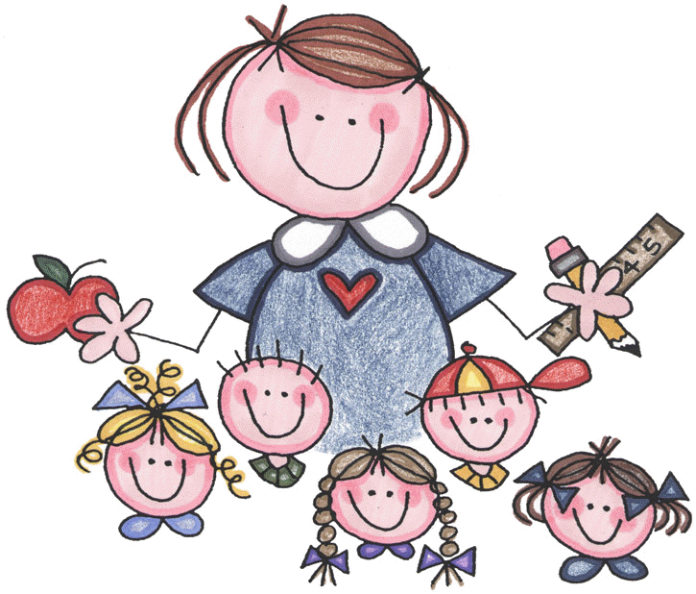





1. box

2. fox

3. dog

4. lock

5. pot

6. cone

7. home

8. nose

9. poke

10. rope

Review Words

11. slide

12. line

High Frequency Words

13. have

14. off

15. took

**Additional Information**

*Please be sure your child returns any **Wall of Honor Sheets** for our special Veteran’s Day display. The students completed a special project in ISM that will aslo be displayed in the gym.

\***Thank you** for all of the Halloween party donations! We really appreciate your support and generosity! The students should really enjoy it!

-Reading/Writing-

**Unit 1- Week 3 (continued)**

**Comprehension Strategy:** ask and answer questions

**Comprehension Skill:** character, setting, events

**Vocabulary Strategy:** context clues

**Writing Traits:** word choice, complete paragraph

**Grammar:** subjects

**Structural Analysis:** closed syllables

**Mechanics:** letter punctuation, parts of a friendly letter

**Concept Map:** Flow Map

*Unit 1.3 Reading Assessment, Distric Narrative Writing Assessment-Fairy Tale

-Math-

We completed **Unit 2-Place Value to 1,000**.

**Unit 3-Basic Addition and Subtraction** will begin on Monday with a unit pretest.

-Social Studies**/Science**-

We completed science **Unit 1-What is a Scientist**?

We will begin a mini-unit next week in social studies on **voting** and **citizenship**.

**Homework**

**\*Friendly Letter Practice Sheet**

Due: Monday, October 31st

**\*Fluency Practice-**

**Pop Words 1.5**

Due: Friday, November 4th

\***October Book It Calendar**

Due: Tuesday, November 1st

**Spelling List for**

**Next Week-**

**Short o & Long o**

**This week in Review**