

###### **October 7, 2016**

##### Mrs. Maley - Mrs. Pater-Mrs. Terenzi-Ms. Versteegden

**Upcoming Dates**

**What’s Happening In 2nd Grade**

**October 18th**

Donuts with Dad A-L

**October 19th**

Donuts with Dad M-Z

**October 21st**

Spirit Wear Sale

GPTO Trunk or Treat

**October 31st**

Halloween Party, 9-11

Half Day 11:32

**November 8th**

No School-Voting Day

**November 11th**

Veteran’s Day

Scrip Sale Begins

**November 14th**

Book Fair Week

**November 16th**

Conferences

5-8

**November 17th**

Half Day

Conferences

12:30-8

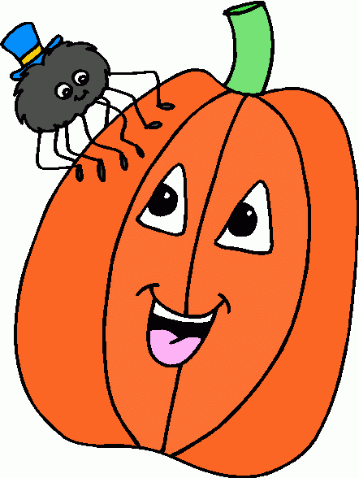

**1. job**

**2. pot**

**3. nod**

**4. top**

**5. not**

**6.dot**

**7. fox**

**8. mop**

**9. spot**

**10. hop**

**11. pop**

**12. drop**

**13. on**

**14. box**

**15.pocket**

**16.hospital**

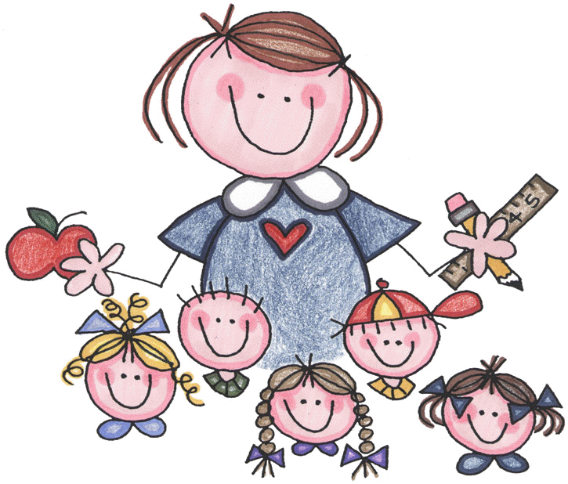



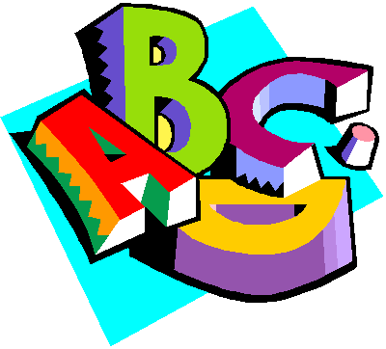

**Homework:**

**\*Map Skills Review Sheet**

Due: Monday, October 10th

Test Date: Friday, October 14th

**\*Pop Words 1.2-**

**Fluency Practice**

Due: Friday, October 14th

**Additional Information**

*Please be sure your child returns their Daily Folder each day.

*A **Halloween party note** is included in today’s Friday Folder. Please sign up to volunteer your time or donate a special item if possible.

*Progress Reports will go home next week in your child’s Friday Folder.

-Reading/Writing-

**Unit 1-Week 2**

**Comprehension Strategy:** visualize

**Comprehension Skill:** character, setting, events

**Vocabulary Strategy:** root words

**Writing Traits:** ideas, organization, complete paragraph

**Grammar:** commands and exclamations

**Structural Analysis:** –s, -es

**Mechanics:** capitalization, punctuation with commands and exclamations

**Concept Map:** Flow Map

**Review:** singular and plurals nouns

-Math-

**Unit 2: Place Value to 1,000**

**Vocabulary:** ones, tens, hundreds, digit, word form, standard form, patterns, greater than, less than, 10 more, 10 less, 100 more, 100 less

-**Social Studies**-

**Unit 1:** Map Skills

**Vocabulary:** map, map key, compass rose, map scale, continent, directions

**Spelling List for**

**Next Week**

**Short a, Long a**

1. bag

2. cap

3. ham

4. bake

5. ate

6. mad

7. back

8. cape

9. made

10. rake

Review Words

11. still

12. belt

High Frequency Words

13. into

14. done

15. your

**This week in Review**