

###### **September 16, 2016**

##### Mrs. Maley - Mrs. Pater-Mrs. Terenzi-Ms. Versteegden

**Upcoming Dates**

**What’s Happening In 2nd Grade**

**September 20th**

GPTO Meeting 7:00

**September 21st**

Picture Day

**September 28th**

Join Cub Scout Night

7:00-8:00

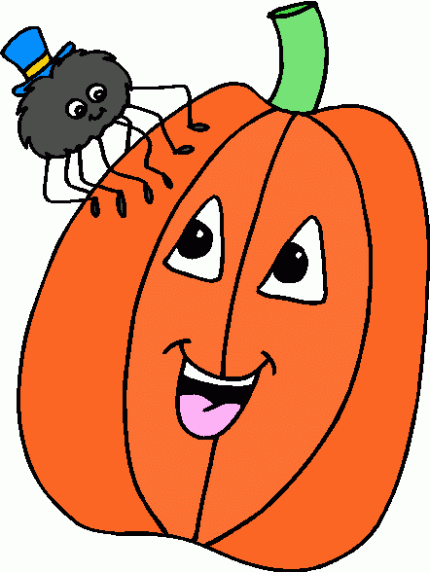

**1. job**

**2. pot**

**3. nod**

**4. top**

**5. not**

**6.dot**

**7. fox**

**8. mop**

**9. spot**

**10. hop**

**11. pop**

**12. drop**

**13. on**

**14. box**

**15.pocket**

**16.hospital**







1. has
2. wag
3. bad
4. six
5. will
6. sat
7. had
8. fix
9. him *Tests will
10. if be given on
11. can Fridays.
12. hit
13. why
14. for
15. help

**Homework –**

**Odd or Even?**

*Students will practice determining if a number is odd or even.

**Due: Monday, September 19th**

**Correcting Marks**

*Papers marked with DT mean we have completed and/or checked the work together. *Students may empty their daily folders at home each night.

**Spelling List for Next Week**

**Short a, Short i**

-Reading/Writing-

*This week we determined whether a letter is a vowel or consonant and introduced 2nd grade editing marks. In reading we discussed story elements and comprehension. In writing, we completed several narrative writing pieces. We targeted writing a complete paragraph containing a topic sentence, detail sentences and a closing sentence.

-Math-

We began **Unit 1-Two Digit Place Value**. We discussed odd and even numbers, added with odd and even numbers, and determined the value of a digit.

-**Social Studies**-

We reviewed class rules, routines, and the Graebner KEYS. We watched several clips about Constitution Day and helped students understand that the Constitution outlines the basic rules our government follows.

**This week in Review**