

###### **September 30, 2016**

##### Mrs. Maley - Mrs. Pater-Mrs. Terenzi-Ms. Versteegden

**Upcoming Dates**

**What’s Happening In 2nd Grade**



**October 18th**

Donuts with Dad A-L

**October 19th**

Donuts with Dad M-Z

**October 21st**

GPTO Trunk or Treat

**October 31st**

Halloween Party, 9-11

Half Day 11:32

**October 4th**

GPTO Meeting 7 pm

**October 5th**

Count Day

Walk to School Wednesday

Dental Visits

**October 6th**

Dental Visits

**1. job**

**2. pot**

**3. nod**

**4. top**

**5. not**

**6.dot**

**7. fox**

**8. mop**

**9. spot**

**10. hop**

**11. pop**

**12. drop**

**13. on**

**14. box**

**15.pocket**

**16.hospital**

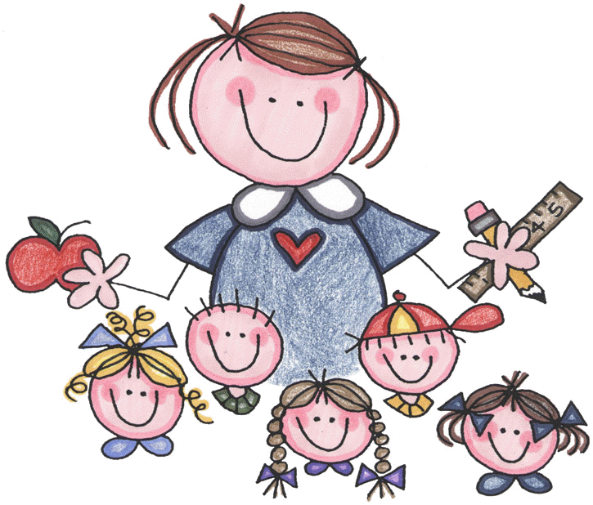





**Additional Information**

*Please be sure you are signed up for **Power School**. It is a helpful tool for parents to check their child’s grades, track completed assignments and monitor attendance. You can sign up for Power School in the office.

*An **Essential Questions Packet** will come home at the beginning of each math unit. The purpose is to share the guiding questions and topics that will be covered in each unit.

1. grass

2. trips

3. crack

4. still

5. west

6. mask

7. clap

8. plans

9. milk

10. belt

Review Words

11. fog

12. tub

High Frequency Words

13. by

14. he

15. she

**Homework:**

**Out at the Ranch**

**Mapping Activity**

**Due: Monday, October 3rd**

-Reading/Writing-

**Unit 1-Week 1 (continued this week)**

**Comprehension Strategy:** visualize

**Comprehension Skill:** key details

**Vocabulary Strategy:** inflectional endings: s, es, ed, ing

**Writing Traits:** ideas, complete paragraph

**Grammar:** statements and questions

**Structural Analysis:** plural nouns with –s, -es

**Mechanics:** capitalization, punctuation with statements and questions

We ended the week by completing the two unit assessments. The first assessment we completed together as practice. The second one was completed independently and will be graded.

-Math-

**Unit 1: Two Digit Place Value**

We finished Unit 1 today by completing the unit test.

Next week we will begin **Unit 2-Place Value to 1,000**. On Monday, the students will begin switching classrooms for their math instruction based on their NWEA math score and unit pre-test score. A note will be in your child’s Friday Folder today letting you know which classroom they will attend for their math instruction. All classrooms will complete the same units, but the pace and tasks will be differentiated.

-**Social Studies**-

**Unit 1:** Map Skills

**Vocabulary:** map, map key, compass rose, map scale, continent

**This week in Review**

**Spelling List for**

**Next Week**

**Two-Letter Blends**